Math& 142
Right Triangle
- Pythagorean Theorem:
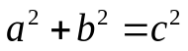
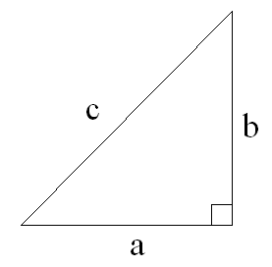

- 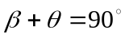
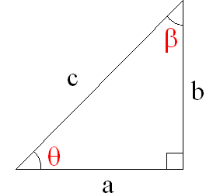

Trigonometric Ratios
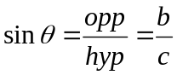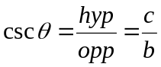
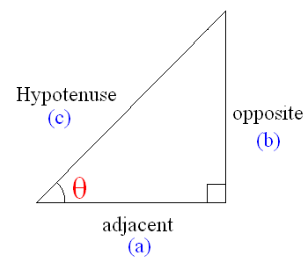

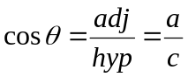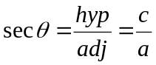

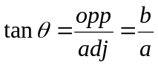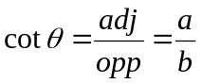

Inverse Trigonometric Functions

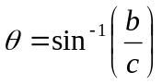

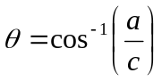

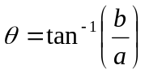
Solving Right Triangles

Names: ________________________ ID# ____________________
- Round your answers to 4 decimal places for length and 2 decimal places for angles

- Find all the missing measurements on the right triangle below.

12 ft

23°

- Find all the missing measurements on the right triangle below.

36°
8 m

- Find all the missing measurements on the right triangle below.

1.3 cm
0.6 cm

- Write an expression for the missing side of the triangle in terms of x below, then write expressions for all 6 trig functions in terms of x.
x
1
θ
sin θ = tan θ =

cos θ = cot θ =

sec θ = csc θ =

